

International School

**Capstone Project 1**

*CMU-SE 450*

**User Interface Design Document**

*Version: 2.0*

*Date: 27/12/2021*

**School Connect Application**

**Submitted by:**

Nguyen Thanh Phu

Nguyen Trung Hieu

Dang Nguyen Bao Hoai

**Approved by**

Nguyen Minh Nhat

**User Interface Design Document Panel Representative:**

Name Signature Date

**Capstone Project 1- Mentor:**

Name Signature Date

**Project Information**

|  |  |  |  |  |
| --- | --- | --- | --- | --- |
| **Project acronym** | SConA | | | |
| **Project Title** | School Connect Application | | | |
| **Start Date** | 22-Aug-2021 | **End Date** | | 18-Dec-2021 |
| **Lead Institution** | International School, Duy Tan University | | | |
| **Project Mentor & contact details** | Name: Nguyen Minh Nhat  Email: nhatnm2010@gmail.com  Tel: +84 905 125 143 | | | |
| **Scrum Master & contact details** | Name: Nguyen Thanh Phu  Email: [thangphu104@gmai.com](mailto:thangphu104@gmai.com)  Tel: +84 772 492 301 | | | |
| **Team members** | **Name** | **Email** | **Tel** | |
| Nguyen Trung Hieu | hnguyentrung20@gmail.com | +84 975 299 149 | |
| Dang Nguyen Bao Hoai | dangbhoai@gmail.com | +84 773 305 395 | |

|  |  |  |  |
| --- | --- | --- | --- |
| **DOCUMENT INFORMATION** | | | |
| **Document Title** | User Interface Design Document | | |
| **Author(s)** | Team C1SE.44 | | |
| **Role** | C1SE.44- User Interface Design Document -SConA-v2.0 | | |
| **Date** | 27-Dec-2021 | **Filename** | C1SE.44- User Interface Design Document -SConA-v2.0 |
| **URL** |  | | |
| **Access** | Project and CMU Program | | |

**DOCUMENT APPROVALS**

The following signatures are required for approval of this document.

|  |  |  |
| --- | --- | --- |
| Nguyen Minh Nhat  *Mentor* | Signature | Date |
| Nguyen Thanh Phu  *Scrum Master, DevTeam* | Signature | Date |
| Nguyen Trung Hieu  *Product owner, DevTeam* | Signature | Date |
| Dang Nguyen Bao Hoai  *Product owner, DevTeam* | Signature | Date |

REVISION HISTORY

|  |  |  |  |  |
| --- | --- | --- | --- | --- |
| **Version** | **Date** | **Comments** | **Author** | **Approval** |
| 1.0 | 01/09/2021 | Create User Interface Design Document | Dang Nguyen Bao Hoai |  |
| 1.1 | 15/10/2021 | Update User Interface Design Sprint 2 Document | Dang Nguyen Bao Hoai |  |
| 2.0 | 27/12/2021 | Update User Interface Design Final Document | Dang Nguyen Bao Hoai |  |
|  |  |  |  |  |

**TABLE OF CONTENTS**

**1.** **Introduction** 7

**1.1** **Purpose** 7

**1.2.** **Scope** 7

**2.** **Describe User Interface Application in Detail** 7

**2.1.** **UI-User** 7

**2.1.1.** **UI-01: Login** 7

**2.1.2.** **UI-02: Home Page** 9

**2.1.3.** **UI-03: Logout** 10

**2.1.4.** **UI-04: Change Password** 10

**2.1.5.** **UI-05: Forgot Password** 11

**2.1.6.** **UI-06: View post** 12

**2.1.7.** **UI-07: Create post or event** 14

**2.1.8.** **UI-08: View profile** 15

**2.1.9.** **UI-09: Update profile** 16

**2.1.10.** **UI-10: Chat** 18

**2.1.11.** **UI-11: View Forum(User)** 19

**2.1.12.** **UI-12: View Calendar** 20

**2.1.13.** **UI-13: Delete, Report The Post** 21

**2.1.14.** **UI-14: Report The Message** 22

**2.1.15.** **UI-15: Notification New** 23

**2.1.16.** **UI-16: Notification New Message** 24

**2.2.** **UI-Censor** 25

**2.2.1.** **UI-01: View Forum(Censor)** 25

**2.2.2.** **UI-02: Censorship The Post** 26

**2.2.3.** **UI-03: Create post or event** 27

**2.2.4.** **UI-04: Delete, Report The Post** 28

**2.2.5.** **UI-05: Chat** 29

**2.2.6.** **UI-06: Report the message** 30

**2.3.** **UI-Admin** 31

**2.3.1.** **UI-01: Login** 31

**2.3.2.** **UI-02: Home Page** 32

**2.3.3.** **UI-03: Logout** 33

**2.3.4.** **UI-04: Account Managerment** 34

**2.3.5.** **UI-05: Add Account** 35

**2.3.6.** **UI-06: Update Account** 37

**2.3.7.** **UI-07: Forum Managerment** 38

**2.3.8.** **UI-08: Add Forum** 39

**2.3.9.** **UI-09: Update Forum** 41

**2.3.10.** **UI-10: Dashboard** 42

**2.3.11.** **UI-11: Block Chat Toxic** 43

**2.3.12.** **UI-12: Unblock Chat Toxic** 44

**2.3.13.** **UI-13: Create Event** 45

**2.3.14.** **UI-14: View Notification Admin** 46

# **Introduction**

* 1. **Purpose**
* This document describes the design interface of “School Connect Application” System.
  1. **Scope**
* Create complete interfaces, and describe them clearly.
* Overview of the stages and modules of the system.

# **Describe User Interface Application in Detail**

* 1. **UI-User**
     1. **UI-01: Login**

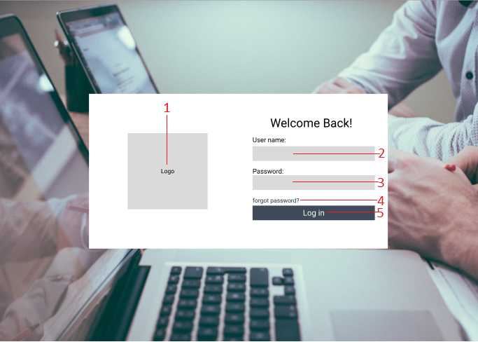

|  |  |  |  |  |
| --- | --- | --- | --- | --- |
| **ID** | **Condition** | **Control Type** | **Target** | **Notes** |
| 1 | Nothing | Picture | Logo of application |  |
| 2 | Input | Textbox | Input username |  |
| 3 | Input | Textbox | Input user’s password |  |
| 4 | Nothing | Link | Click to go to forgot password page |  |
| 5 | Click | Button | Click to login into the system |  |

* + 1. **UI-02: Home Page**

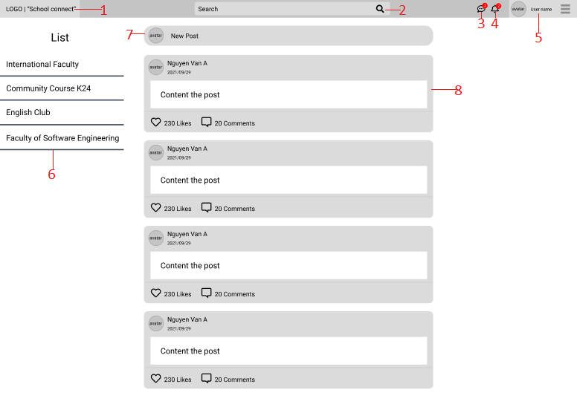

|  |  |  |  |  |
| --- | --- | --- | --- | --- |
| **ID** | **Condition** | **Control Type** | **Target** | **Notes** |
| 1 | Nothing | Picture | Logo of application |  |
| 2 | Input | Textbox | Search user name, forum name |  |
| 3 | Click | Icon | Display the list of message |  |
| 4 | Click | Icon | Display the list of notifications |  |
| 5 | Click | Button | Click to view information user page |  |
| 6 | View | Table | Display the list of participating forums |  |
| 7 | Click | Button | Click to create a new post |  |
| 8 | View | Table | Display the number user posts |  |

* + 1. **UI-03: Logout**

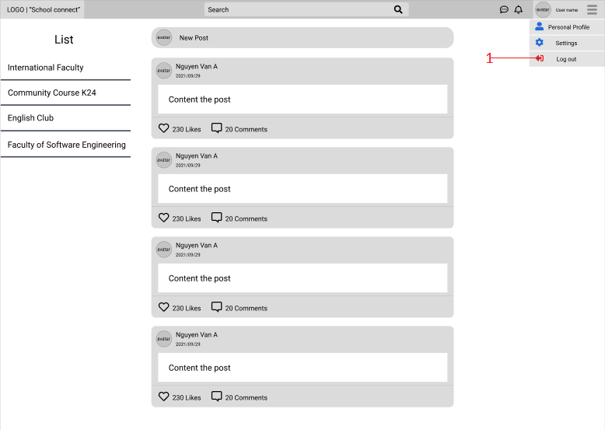

|  |  |  |  |  |
| --- | --- | --- | --- | --- |
| **ID** | **Condition** | **Control Type** | **Target** | **Notes** |
| 1 | Click | Button | Click to logout the system |  |

* + 1. **UI-04: Change Password**

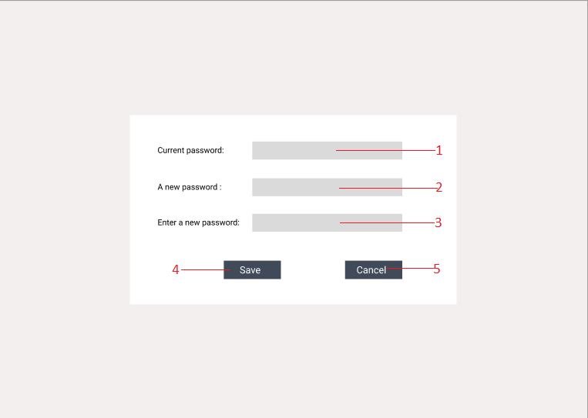

|  |  |  |  |  |
| --- | --- | --- | --- | --- |
| **ID** | **Condition** | **Control Type** | **Target** | **Notes** |
| 1 | Input | Textbox | Input Current password |  |
| 2 | Input | Textbox | Input a new password |  |
| 3 | Input | Textbox | Input a new password again |  |
| 4 | Click | Button | Click to save change password |  |
| 5 | Click | Button | Click to cancel change password |  |

* + 1. **UI-05: Forgot Password**

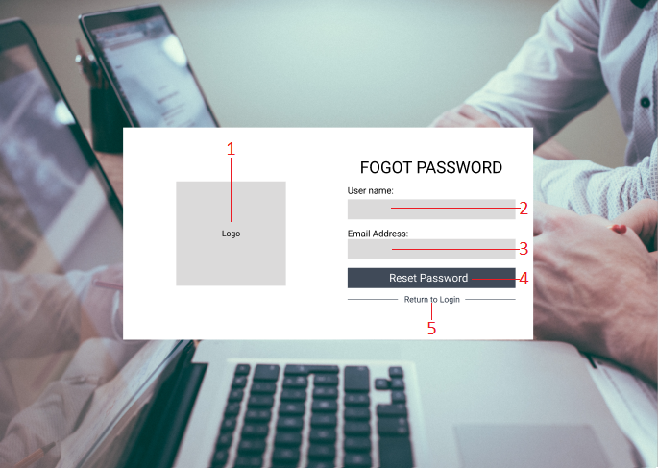

|  |  |  |  |  |
| --- | --- | --- | --- | --- |
| **ID** | **Condition** | **Control Type** | **Target** | **Notes** |
| 1 | Nothing | Picture | Logo of application |  |
| 2 | Input | Textbox | Input Username |  |
| 3 | Input | Textbox | Input Email Address |  |
| 4 | Click | Button | Click to reset password |  |
| 5 | Nothing | Link | Click to go to Login page |  |

* + 1. **UI-06: View post**

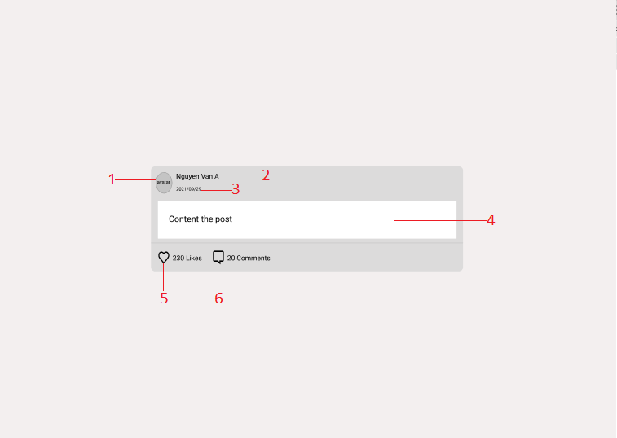

|  |  |  |  |  |
| --- | --- | --- | --- | --- |
| **ID** | **Condition** | **Control Type** | **Target** | **Notes** |
| 1 | Nothing | Picture | Avatar of user |  |
| 2 | View | Text | Display the user's name |  |
| 3 | View | Text | Display the post date of the article |  |
| 4 | View | Text | Display the content of the article |  |
| 5 | View | Icon | Display the number of likes of the post |  |
| 6 | View | Icon | Display the number of comments for the article |  |

* + 1. **UI-07: Create post or event**

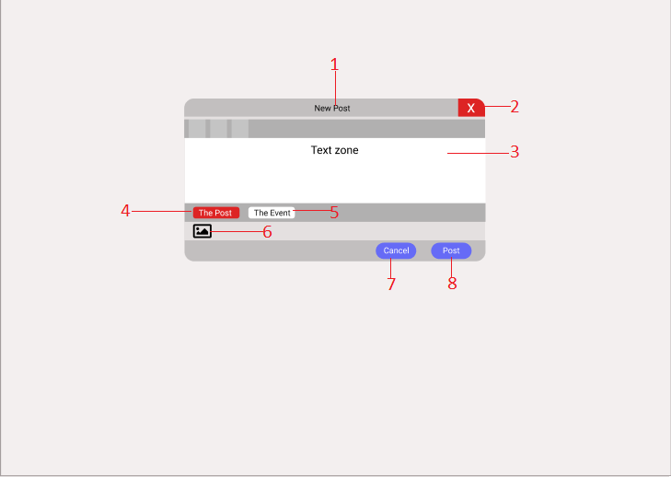

|  |  |  |  |  |
| --- | --- | --- | --- | --- |
| **ID** | **Condition** | **Control Type** | **Target** | **Notes** |
| 1 | View | Title | Display new post box title |  |
| 2 | Click | Button | Click to disable new post box |  |
| 3 | Input | Textarea | Input content the new post |  |
| 4 | Click | Button | Click to switch to the new post mode |  |
| 5 | Click | Button | Click to switch to the new event mode |  |
| 6 | Click | Image | Click to upload the picture |  |
| 7 | Click | Button | Click cancel the new post |  |
| 8 | Click | Button | Click to post a new article |  |

* + 1. **UI-08: View profile**

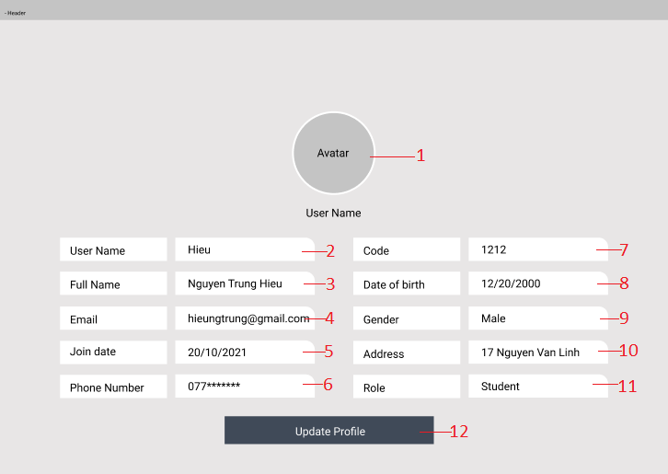

|  |  |  |  |  |
| --- | --- | --- | --- | --- |
| **ID** | **Condition** | **Control Type** | **Target** | **Notes** |
| 1 | View | Image | Display User's picture |  |
| 2 | View | Textbox | Display User Name |  |
| 3 | View | Textbox | Display Full Name |  |
| 4 | View | Textbox | Display Email |  |
| 5 | View | Textbox | Display Join Date |  |
| 6 | View | Textbox | Display Phone Number |  |
| 7 | View | Textbox | Display Code |  |
| 8 | View | Textbox | Display Date Of Birth |  |
| 9 | View | Textbox | Display Gender |  |
| 10 | View | Textbox | Display Address |  |
| 11 | View | Textbox | Display Role |  |
| 12 | Click | Button | Click to go to Update Profile |  |

* + 1. **UI-09: Update profile**

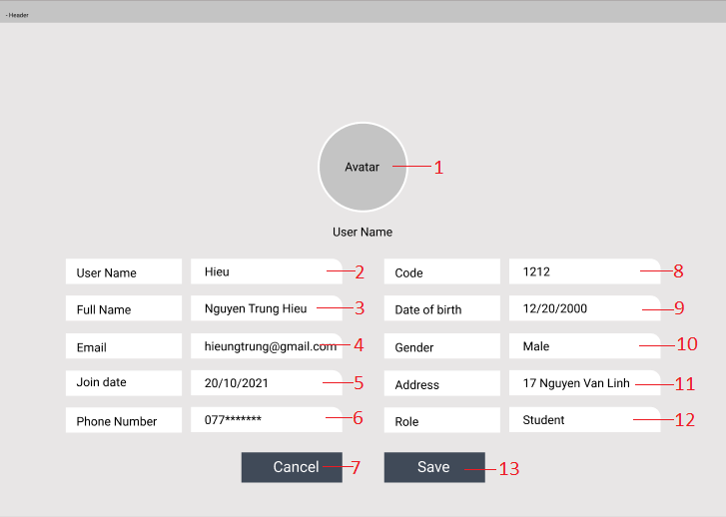

|  |  |  |  |  |
| --- | --- | --- | --- | --- |
| **ID** | **Condition** | **Control Type** | **Target** | **Notes** |
| 1 | Click | Image | Click to change User's picture |  |
| 2 | View | Textbox | Display User Name |  |
| 3 | View | Textbox | Display Full Name |  |
| 4 | Input | Textbox | Input to change Email |  |
| 5 | View | Textbox | Display Join Date |  |
| 6 | Input | Textbox | Input to change Phone Number |  |
| 7 | Click | Button | Click cancel and return to View Profile page |  |
| 8 | View | Textbox | Display Code |  |
| 9 | Input | Textbox | Input to change Date Of Birth |  |
| 10 | Input | Textbox | Input to change Gender |  |
| 11 | Input | Textbox | Input to change Address |  |
| 12 | View | Textbox | Display Role |  |
| 13 | Click | Button | Click to save update profile |  |

* + 1. **UI-10: Chat**

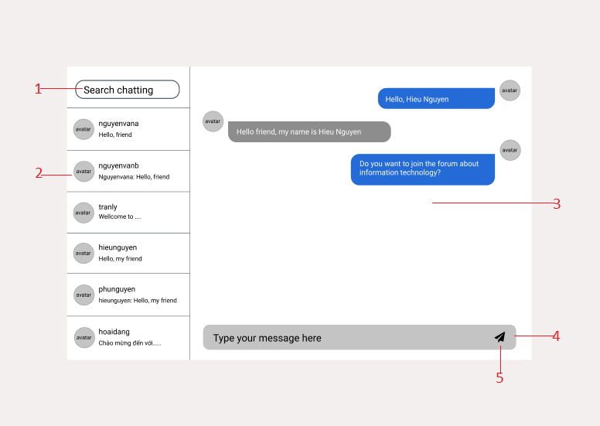

|  |  |  |  |  |
| --- | --- | --- | --- | --- |
| **ID** | **Condition** | **Control Type** | **Target** | **Notes** |
| 1 | Input | Textbox | Search chat |  |
| 2 | View | Table List | View list of chats |  |
| 3 | View | Nothing | View messages between people |  |
| 4 | Input | Textbox | Enter the message you want to send |  |
| 5 | Click | Button | Click to send a message |  |

* + 1. **UI-11: View Forum(User)**

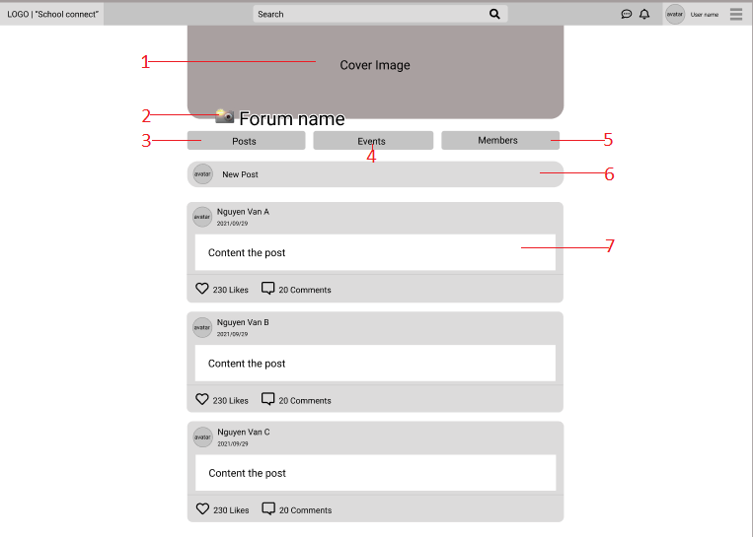

|  |  |  |  |  |
| --- | --- | --- | --- | --- |
| **ID** | **Condition** | **Control Type** | **Target** | **Notes** |
| 1 | View | Image | Display forum cover image |  |
| 2 | View | Text | Display forum name |  |
| 3 | Click | Button | Click to go to the forum new posts view page |  |
| 4 | Click | Button | Click to go to the forum events view page |  |
| 5 | Click | Button | Click to go to the forum members view page |  |
| 6 | Click | Button | Click to create a new post |  |
| 7 | View | Table | Display the number user posts |  |

* + 1. **UI-12: View Calendar**

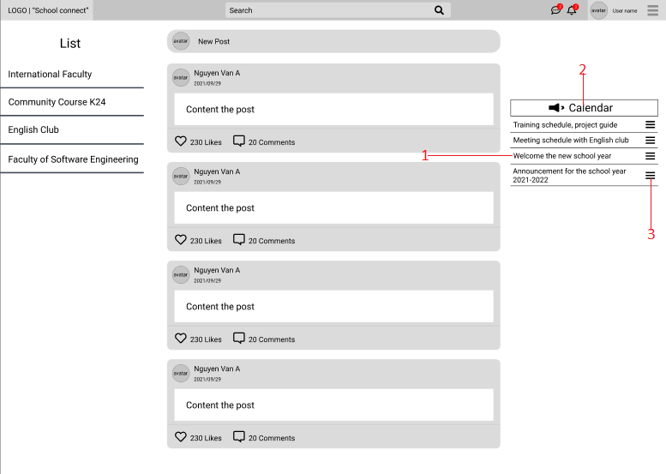

|  |  |  |  |  |
| --- | --- | --- | --- | --- |
| **ID** | **Condition** | **Control Type** | **Target** | **Notes** |
| 1 | View | Text | Calendar Title |  |
| 2 | View | Table list | Display list of upcoming events calendar |  |
| 3 | Click | Icon | Display details of the event calendar |  |

* + 1. **UI-13: Delete, Report The Post**

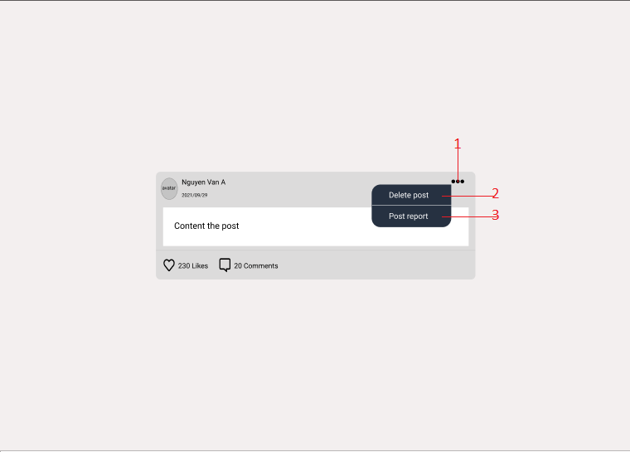

|  |  |  |  |  |
| --- | --- | --- | --- | --- |
| **ID** | **Condition** | **Control Type** | **Target** | **Notes** |
| 1 | Click | Icon | Click to display the functions of deleting posts, reporting articles |  |
| 2 | Click | Text | Click to delete the post |  |
| 3 | Click | Text | Click to report the post |  |

* + 1. **UI-14: Report The Message**

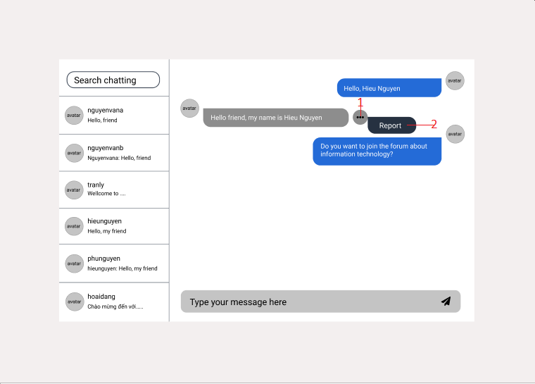

|  |  |  |  |  |
| --- | --- | --- | --- | --- |
| **ID** | **Condition** | **Control Type** | **Target** | **Notes** |
| 1 | Click | Icon | Click to display the functions of reporting message |  |
| 2 | Click | Text | Click to report the message |  |

* + 1. **UI-15: Notification New**

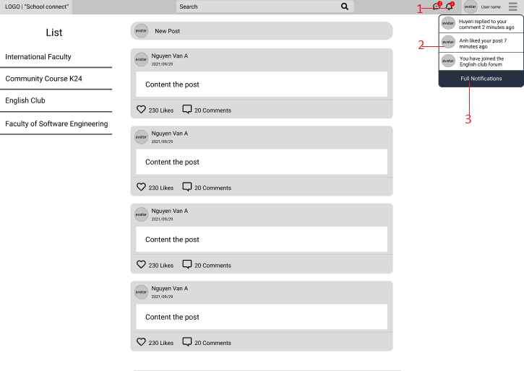

|  |  |  |  |  |
| --- | --- | --- | --- | --- |
| **ID** | **Condition** | **Control Type** | **Target** | **Notes** |
| 1 | Click | Icon | Click on the icon to display a list of new notifications |  |
| 2 | View | List | Displays a list of new notifications sent to |  |
| 3 | Click | Text | Click to see the full list of announcements |  |

* + 1. **UI-16: Notification New Message**

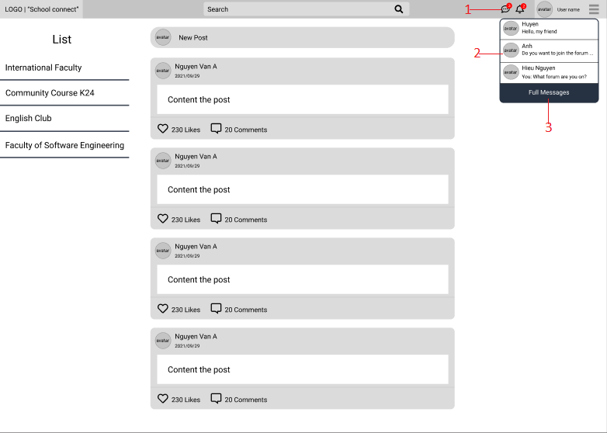

|  |  |  |  |  |
| --- | --- | --- | --- | --- |
| **ID** | **Condition** | **Control Type** | **Target** | **Notes** |
| 1 | Click | Icon | Click on the icon to display a list of new messages |  |
| 2 | View | List | Displays a list of new messages sent to |  |
| 3 | Click | Text | Click to see the full list of messages |  |

* 1. **UI-Censor**
     1. **UI-01: View Forum(Censor)**

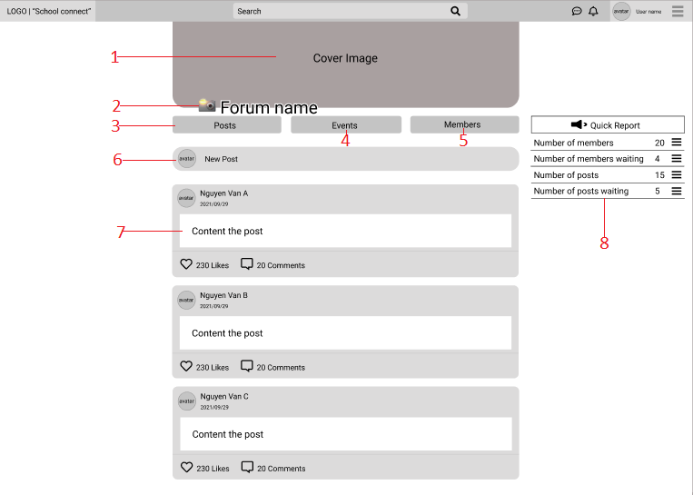

|  |  |  |  |  |
| --- | --- | --- | --- | --- |
| **ID** | **Condition** | **Control Type** | **Target** | **Notes** |
| 1 | View | Image | Display forum cover image |  |
| 2 | View | Text | Display forum name |  |
| 3 | Click | Button | Click to go to the forum new posts view page |  |
| 4 | Click | Button | Click to go to the forum events view page |  |
| 5 | Click | Button | Click to go to the forum members view page |  |
| 6 | Click | Button | Click to create a new post |  |
| 7 | View | Table | Display the number user posts |  |
| 8 | View | Table | Display the quick reports |  |

* + 1. **UI-02: Censorship The Post**

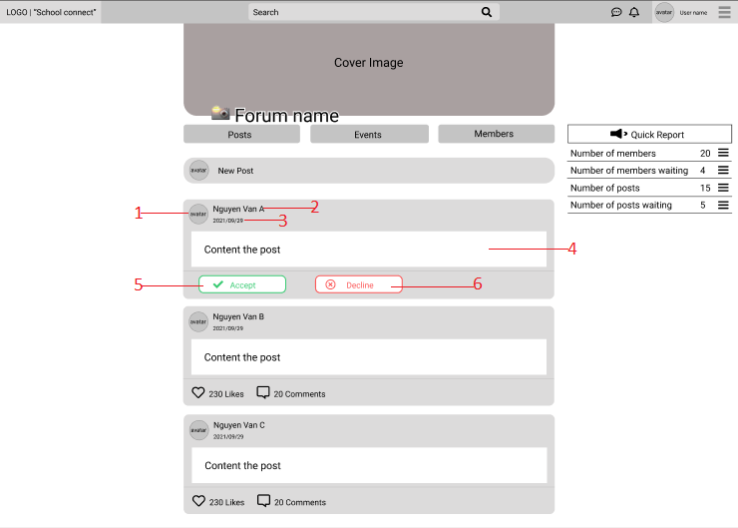

|  |  |  |  |  |
| --- | --- | --- | --- | --- |
| **ID** | **Condition** | **Control Type** | **Target** | **Notes** |
| 1 | Nothing | Picture | Avatar of user |  |
| 2 | View | Text | Display the user's name |  |
| 3 | View | Text | Display the post date of the article |  |
| 4 | View | Text | Display the content of the article |  |
| 5 | Click | Button | Click to moderate the post |  |
| 6 | Click | Button | Click to cancel post browsing |  |

* + 1. **UI-03: Create post or event**



|  |  |  |  |  |
| --- | --- | --- | --- | --- |
| **ID** | **Condition** | **Control Type** | **Target** | **Notes** |
| 1 | View | Title | Display new post box title |  |
| 2 | Click | Button | Click to disable new post box |  |
| 3 | Input | Textarea | Input content the new post |  |
| 4 | Click | Button | Click to switch to the new post mode |  |
| 5 | Click | Button | Click to switch to the new event mode |  |
| 6 | Click | Image | Click to upload the picture |  |
| 7 | Click | Button | Click cancel the new post |  |
| 8 | Click | Button | Click to post a new article |  |

* + 1. **UI-04: Delete, Report The Post**



|  |  |  |  |  |
| --- | --- | --- | --- | --- |
| **ID** | **Condition** | **Control Type** | **Target** | **Notes** |
| 1 | Click | Icon | Click to display the functions of deleting posts, reporting articles |  |
| 2 | Click | Text | Click to delete the post |  |
| 3 | Click | Text | Click to report the post |  |

* + 1. **UI-05: Chat**



|  |  |  |  |  |
| --- | --- | --- | --- | --- |
| **ID** | **Condition** | **Control Type** | **Target** | **Notes** |
| 1 | Input | Textbox | Search chat |  |
| 2 | View | Table List | View list of chats |  |
| 3 | View | Nothing | View messages between people |  |
| 4 | Input | Textbox | Enter the message you want to send |  |
| 5 | Click | Button | Click to send a message |  |

* + 1. **UI-06: Report the message**



|  |  |  |  |  |
| --- | --- | --- | --- | --- |
| **ID** | **Condition** | **Control Type** | **Target** | **Notes** |
| 1 | Click | Icon | Click to display the functions of reporting message |  |
| 2 | Click | Text | Click to report the message |  |

* 1. **UI-Admin**
     1. **UI-01: Login**

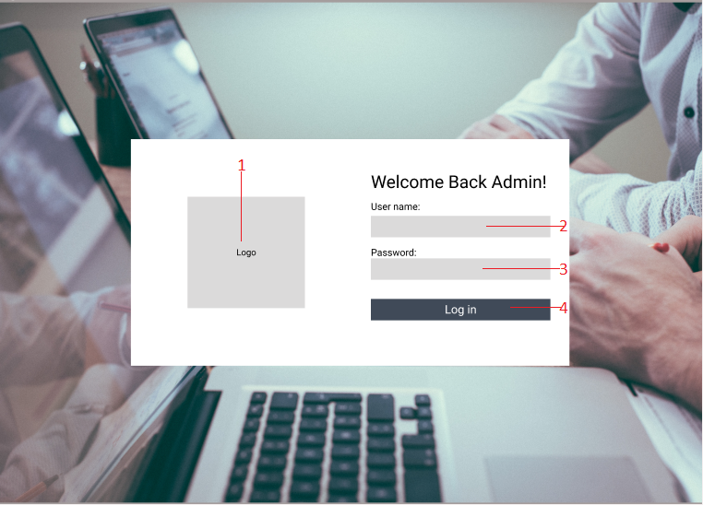

|  |  |  |  |  |
| --- | --- | --- | --- | --- |
| **ID** | **Condition** | **Control Type** | **Target** | **Notes** |
| 1 | Nothing | Picture | Logo of application |  |
| 2 | Input | Textbox | Input username |  |
| 3 | Input | Textbox | Input user’s password |  |
| 4 | Click | Button | Click to login into the system |  |

* + 1. **UI-02: Home Page**

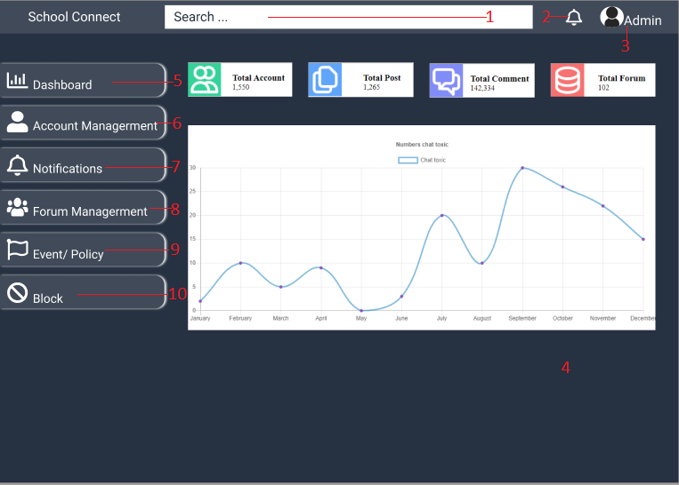

|  |  |  |  |  |
| --- | --- | --- | --- | --- |
| **ID** | **Condition** | **Control Type** | **Target** | **Notes** |
| 1 | Input | Textbox | Search user name, forum name |  |
| 2 | Click | Button | Click to view the notifications |  |
| 3 | Click | Section | Click to view information user page |  |
| 4 | View | Section | Display the number of users, comment, the post in the system and show chart |  |
| 5 | Click | Button | Click to go to Dashboard page |  |
| 6 | Click | Button | Click to go to Account Managerment page |  |
| 7 | Click | Button | Click to go to Notifications page |  |
| 8 | Click | Button | Click to go to Forum Managerment page |  |
| 9 | Click | Button | Click to go to Event/ Policy page |  |
| 10 | Click | Button | Click to go Block page |  |

* + 1. **UI-03: Logout**

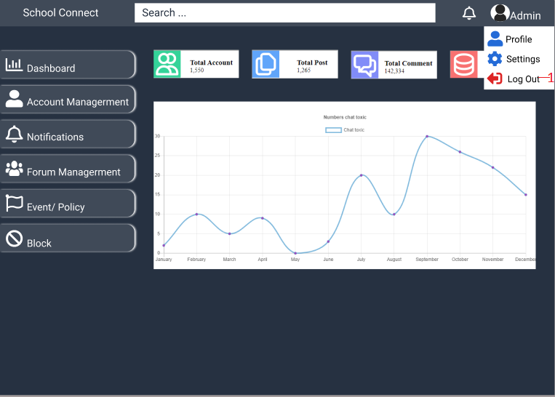

|  |  |  |  |  |
| --- | --- | --- | --- | --- |
| **ID** | **Condition** | **Control Type** | **Target** | **Notes** |
| 1 | Click | Button | Click to logout the system |  |

* + 1. **UI-04: Account Managerment**

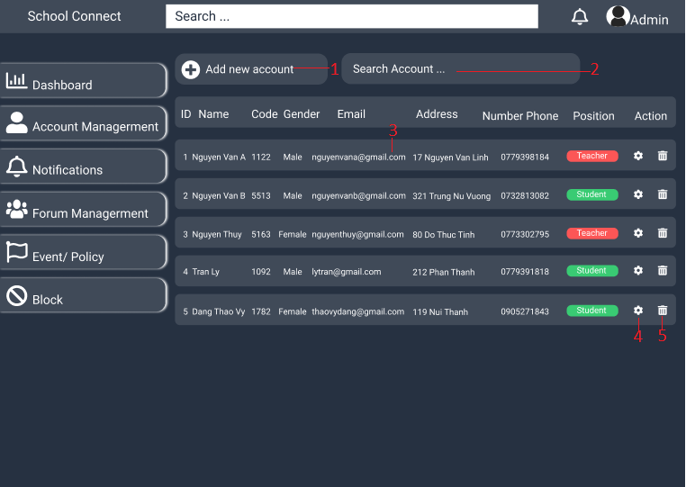

|  |  |  |  |  |
| --- | --- | --- | --- | --- |
| **ID** | **Condition** | **Control Type** | **Target** | **Notes** |
| 1 | Click | Button | Click to create new the user’s account |  |
| 2 | Input | Textbox | Search user’s account |  |
| 3 | View | Table | View user account information |  |
| 4 | Click | Button | Click to view and update the user’s account information |  |
| 5 | Click | Button | Click to delete the user’s account |  |

* + 1. **UI-05: Add Account**

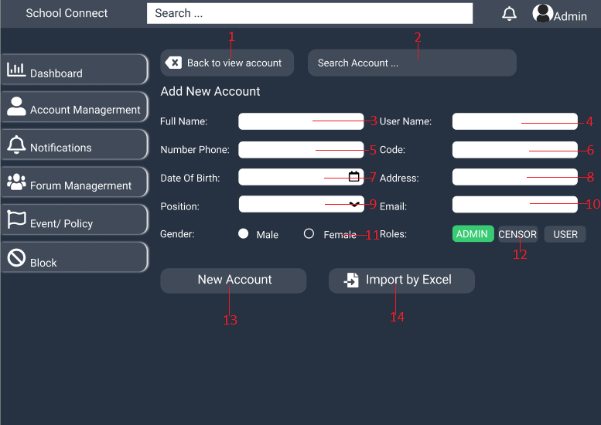

|  |  |  |  |  |
| --- | --- | --- | --- | --- |
| **ID** | **Condition** | **Control Type** | **Target** | **Notes** |
| 1 | Click | Button | Click to go to Account Managerment page |  |
| 2 | Input | Textbox | Search Account |  |
| 3 | Input | Textbox | Input the Full name |  |
| 4 | Input | Textbox | Input the Username |  |
| 5 | Input | Textbox | Input the Phone Number |  |
| 6 | Input | Textbox | Input the Code |  |
| 7 | Input | Textbox | Input the Date Of Birth |  |
| 8 | Input | Textbox | Input the Address |  |
| 9 | Combobox | Select | Choose the user position |  |
| 10 | Input | Textbox | Input Email |  |
| 11 | Radio | Select | Choose the Gender |  |
| 12 | Click | Button | Choose the account Role |  |
| 13 | Click | Button | Click to add new account |  |
| 14 | Click | Button | Click to import file Excel |  |

* + 1. **UI-06: Update Account**

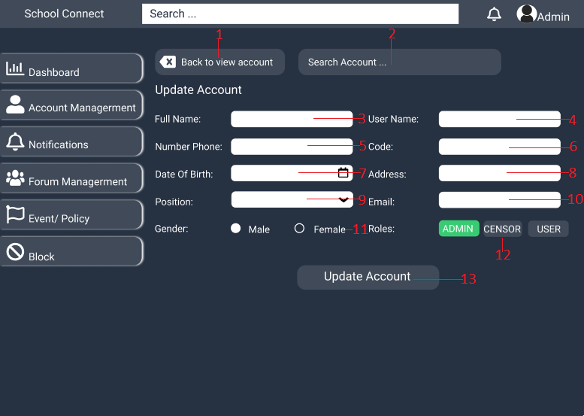

|  |  |  |  |  |
| --- | --- | --- | --- | --- |
| **ID** | **Condition** | **Control Type** | **Target** | **Notes** |
| 1 | Click | Button | Click to go to Account Managerment page |  |
| 2 | Input | Textbox | Search Account |  |
| 3 | Input | Textbox | Input the new Full name |  |
| 4 | Input | Textbox | Input the new Username |  |
| 5 | Input | Textbox | Input the new Phone Number |  |
| 6 | Input | Textbox | Input the new Code |  |
| 7 | Input | Textbox | Input the new Date Of Birth |  |
| 8 | Input | Textbox | Input the new Address |  |
| 9 | Combobox | Select | Choose the new user position |  |
| 10 | Input | Textbox | Input new Email |  |
| 11 | Radio | Select | Choose the new Gender |  |
| 12 | Click | Button | Choose the new account Role |  |
| 13 | Click | Button | Click to Update Account |  |

* + 1. **UI-07: Forum Managerment**

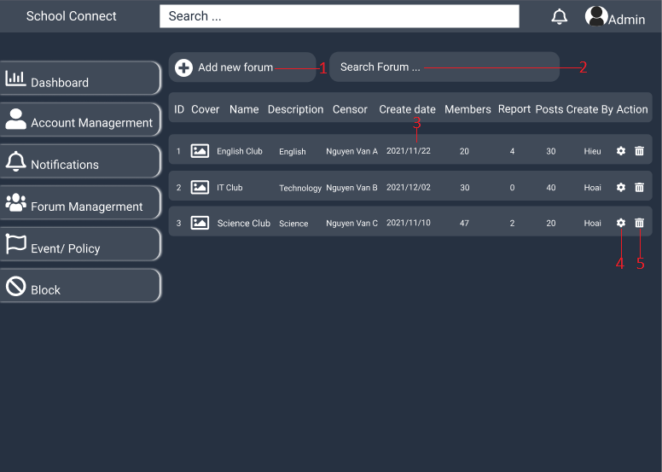

|  |  |  |  |  |
| --- | --- | --- | --- | --- |
| **ID** | **Condition** | **Control Type** | **Target** | **Notes** |
| 1 | Click | Button | Click to create new the forum |  |
| 2 | Input | Textbox | Search forum |  |
| 3 | View | Table | View forum information |  |
| 4 | Click | Button | Click to view and update the forum information |  |
| 5 | Click | Button | Click to delete the forum |  |

* + 1. **UI-08: Add Forum**

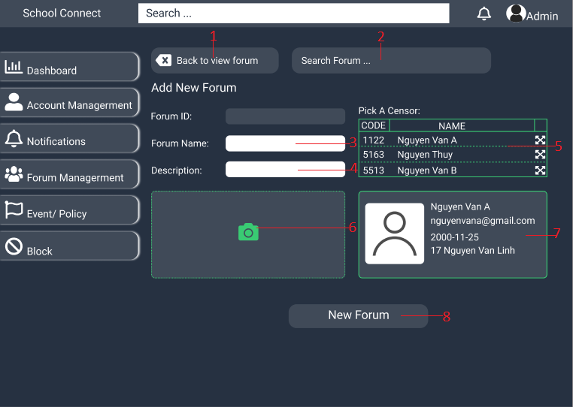

|  |  |  |  |  |
| --- | --- | --- | --- | --- |
| **ID** | **Condition** | **Control Type** | **Target** | **Notes** |
| 1 | Click | Button | Click to go to Forum Managerment page |  |
| 2 | Input | Textbox | Search Forum |  |
| 3 | Input | Textbox | Input the Forum Name |  |
| 4 | Input | Textarea | Input the Description |  |
| 5 | Click | Table | Choose the new forum's censor |  |
| 6 | Click | Button | Click to upload photo |  |
| 7 | View | Table | View information censor |  |
| 8 | Click | Button | Click to add new forum |  |

* + 1. **UI-09: Update Forum**

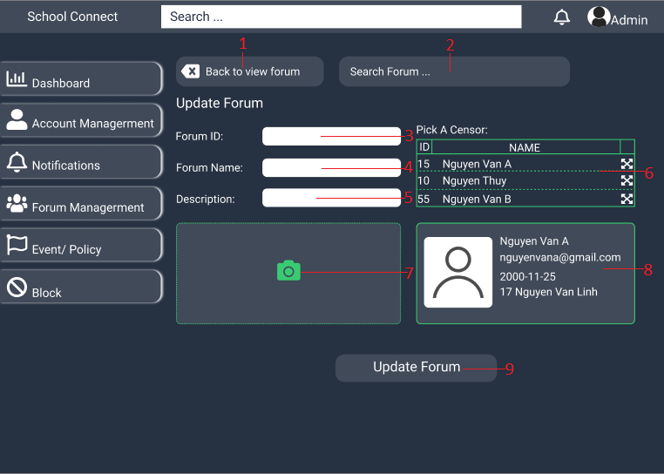

|  |  |  |  |  |
| --- | --- | --- | --- | --- |
| **ID** | **Condition** | **Control Type** | **Target** | **Notes** |
| 1 | Click | Button | Click to go to Forum Managerment page |  |
| 2 | Input | Textbox | Search Forum |  |
| 3 | Input | Textbox | Input the Forum ID |  |
| 4 | Input | Textbox | Input the Forum Name |  |
| 5 | Input | Textarea | Input the Description |  |
| 6 | Click | Table | Choose the new forum's censor |  |
| 7 | Click | Button | Click to upload photo |  |
| 8 | View | Table | View information censor |  |
| 9 | Click | Button | Click to update forum |  |

* + 1. **UI-10: Dashboard**

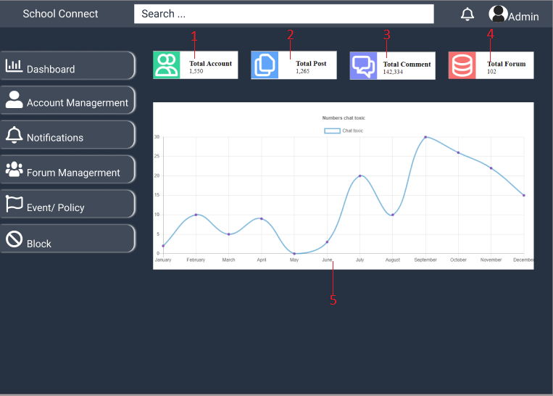

|  |  |  |  |  |
| --- | --- | --- | --- | --- |
| **ID** | **Condition** | **Control Type** | **Target** | **Notes** |
| 1 | Nothing | Label | Show total number account |  |
| 2 | Nothing | Label | Show total number the post |  |
| 3 | Nothing | Label | Show total number the comment |  |
| 4 | Nothing | Label | Show total number the forum |  |
| 5 | Nothing | Chart | Show Chart about number chat toxic |  |

* + 1. **UI-11: Block Chat Toxic**

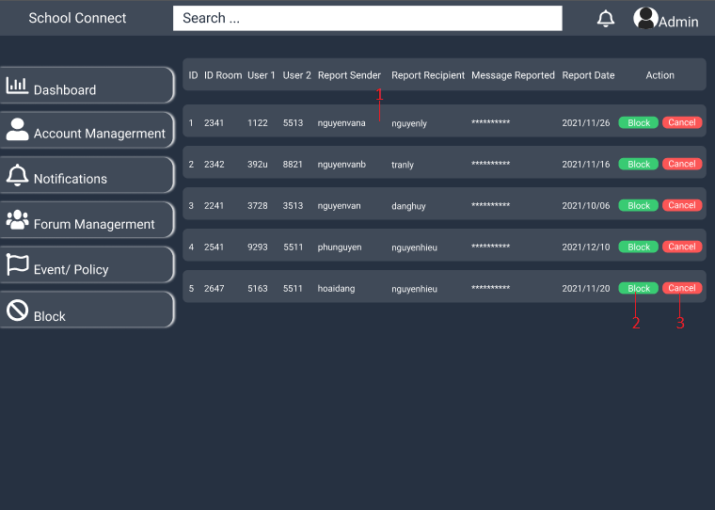

|  |  |  |  |  |
| --- | --- | --- | --- | --- |
| **ID** | **Condition** | **Control Type** | **Target** | **Notes** |
| 1 | View | Table | Display list of reported messages |  |
| 2 | Click | Button | Click to Block Chat |  |
| 3 | Click | Button | Click to Cancel |  |

* + 1. **UI-12: Unblock Chat Toxic**

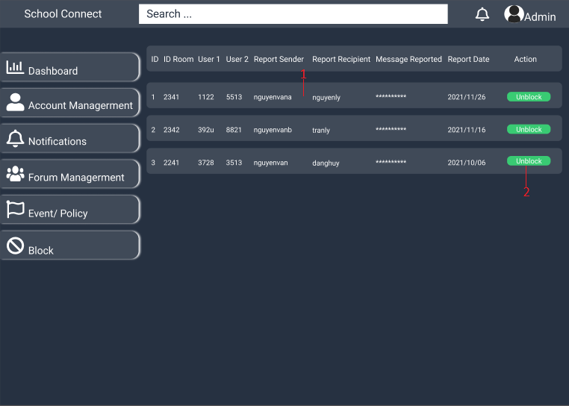

|  |  |  |  |  |
| --- | --- | --- | --- | --- |
| **ID** | **Condition** | **Control Type** | **Target** | **Notes** |
| 1 | View | Table | Display list of reported messages |  |
| 2 | Click | Button | Click to Unblock Chat |  |

* + 1. **UI-13: Create Event**

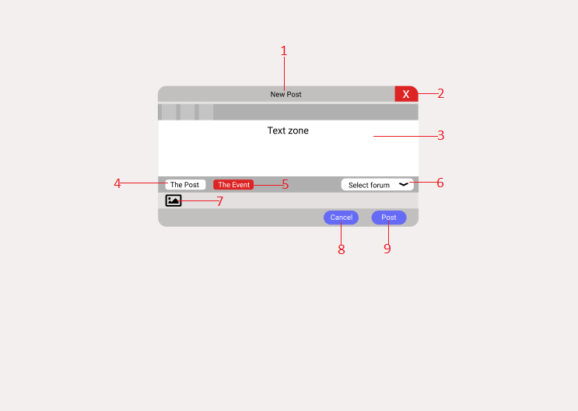

|  |  |  |  |  |
| --- | --- | --- | --- | --- |
| **ID** | **Condition** | **Control Type** | **Target** | **Notes** |
| 1 | View | Title | Display new post box title |  |
| 2 | Click | Button | Click to disable new post box |  |
| 3 | Input | Textarea | Input content the new post |  |
| 4 | Click | Button | Click to switch to the new post mode |  |
| 5 | Click | Button | Click to switch to the new event mode |  |
| 6 | Select | Dropdow List | Select forum to post event |  |
| 7 | Click | Image | Click to upload the picture |  |
| 8 | Click | Button | Click cancel the new post |  |
| 9 | Click | Button | Click to post a new article |  |

* + 1. **UI-14: View Notification Admin**

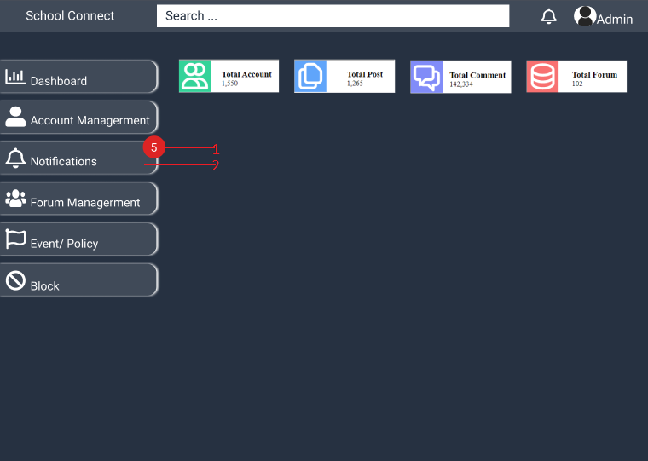

|  |  |  |  |  |
| --- | --- | --- | --- | --- |
| **ID** | **Condition** | **Control Type** | **Target** | **Notes** |
| 1 | View | Text | Display the number of notifications |  |
| 2 | Click | Button | Click to display the list of notifications |  |